
PERIODIC TEST 1 (2023-24)
Subject: PHYSICS  Grade: XII |  | Max. Marks: 35  Time: 1Hour 20 Mins
Name: |  | Section: |  |  |  | Roll No:
General Instructions:
- All questions are compulsory
- This question paper has four sections: section A, Section B, Section C and Section D.
- Section A contains EIGHT questions of one mark each, Section B contains FIVE questions of two marks each, Section C contains FOUR questions of three marks each, Section D contains ONE question of five marks.
- All answers to be written in the answer sheet provided.
 | SECTION- A
 | Two identical metallic spherical shells A and B having charges + 4Q and -10Q are kept a certain distance apart. A third identical uncharged sphere C is first placed in contact with sphere A and then with sphere B, then spheres A and B are brought in contact and then separated. The charge on the spheres A and B respectively are |  |  |  |  |  | 1
 | - +2Q and +2Q |  |  | - -2Q and - 2Q
 | - +1Q and +1Q |  |  | - -1Q and -1Q
2. | An electric dipole is placed at 60⁰ with the direction of uniform electric field. The electric dipole experiences, |  |  |  |  |  | 1
 | - a force, but no torque |  |  | - a torque as well as a net force
 | - a torque, but no net force |  |  | - neither a torque nor a force
3. | Name the physical quantity whose SI unit is Vm. |  |  |  |  |  | 1
 | - Electric field |  |  | - Electric Flux
 | - Electric force |  |  | - Electric charge
4. | A charge Q is uniformly distributed on a large plastic sheet. It is found that the electric field at a point X close to the center of the plate is 25N/C. If the plastic plate is replaced by an aluminum sheet of the same charge Q and same geometrical dimension, the electric field at the point X is |  |  |  |  |  | 1
 | - Less than 25N/C |  |  | - Greater than 25N/C
 | - Equal to 25N/C |  |  | - zero
5 | The figure shows two conducting plates R and S separated by a distance of 2cm setting up an electric field of 300N/C. A charge +Q is placed midway between the 2 plates. The force on the charge +Q is |  |  | 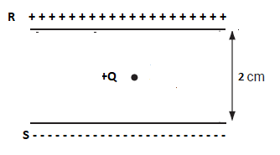 |  |  | 1
 | - 300Q upward |  |  | b) 150Q downwards
 | - 300 Q downwards |  |  | - 150 Q upwards
The questions given below consist of two statements, each printed as Assertion and Reason. While answering these questions, you are required to choose any one of the following four responses.
- If both Assertion and Reason are correct and the Reason is a correct explanation of the Assertion.
- If both Assertion and Reason are correct but Reason is not a correct explanation of the Assertion.
- If the Assertion is correct but Reason is incorrect.
- If both the Assertion and Reason are incorrect.
6. | Assertion: In a cavity in a conductor, the electric field is zero.  Reason: Charges in a conductor reside only at its surface. |  |  |  |  |  | 1
7. | Assertion: The flux over the Gaussian surface depends on all the charges inside and outside the surface  Reason: Electric flux does not depend on all charges nearby. |  |  |  |  |  | 1
8. | Assertion: When bodies are charged through friction, there is a transfer of electric charge from one body to another, but no creation or destruction of charge.  Reason: This follows from conservation of electric charges. |  |  |  |  |  | 1
 | SECTION- B
9. | Consider three charges q1, q2, q3 each equal to q at the vertices of an equilateral triangle of side L. What is the force on a charge Q (with the same sign as q) placed at the centroid of the triangle? |  |  |  |  |  | 2
 | OR
 | Two fixed-point charges +4e and +e units are separated by a distance a. Where should the third point charge be placed for it to be in equilibrium?
10. | A spherical conducting shell of inner radius a and outer radius b has a charge Q. (a) A charge q is placed at the centre of the shell. What is the surface charge density on the inner and outer surfaces of the shell? |  |  | 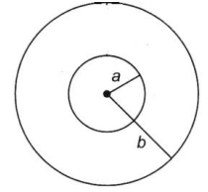 |  |  | 2
11. | a) A positive point charge (+q) is kept in the vicinity of an uncharged conducting plate. Sketch electric field lines originating from the point on to the surface of the plate.  b) Explain why two field lines never cross each other at any point? |  |  |  |  |  | 2
12. | An electric dipole of dipole moment 2Cm is placed in a region of constant electric field of 15N/C. Which of the following electric dipole indicate that the dipole is in  a) stable equilibrium b) unstable equilibrium  c) Identify the dipole /dipoles that experience maximum torque? |  |  |  |  |  | 2
 | 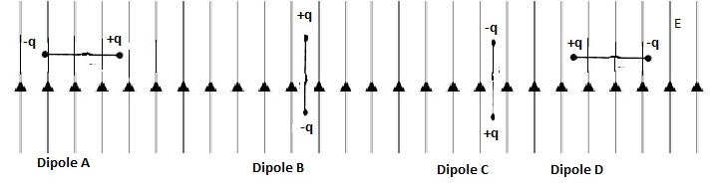
13. | A sphere S₁ of radius r₁ encloses a net charge Q. If there is another concentric sphere S₂ of radius r₂ (r2 > r1) enclosing charge 2Q, find the ratio of the electric flux through S₁ and S₂. |  | 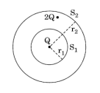 |  |  |  | 2
 | SECTION -C
14. | Two point charges q_{A} = 3 μC and q_{B} = –3 μC are located 20 cm apart in vacuum.  (a) What is the electric field at the midpoint O of the line AB joining the two charges?  (b) If a negative test charge of magnitude 1.5 × 10^{–9} C is placed at this point, what is the force experienced by the test charge? |  |  |  |  |  | 3
15. | A particle of mass m and charge (–q) enters the region between the two charged plates initially moving along x-axis with speed v_{x} as shown in the figure . The length of plate is L and an uniform electric field E is maintained between the plates. Show that the vertical deflection of the particle at the far edge of the plate is 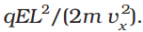 |  |  |  | 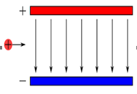 |  | 3
 | OR
 | A right circular cylinder of length a and radius r has its centre at the origin and its axis along the x-axis so that one face is x= - a/2 and the other at x= + a/2, as shown in the figure. A uniform electric electric field is acting parallel to the x-axis such that  Find (a) net electric flux through the cylinder and (b) net charge inside the cylinder? |  |  | 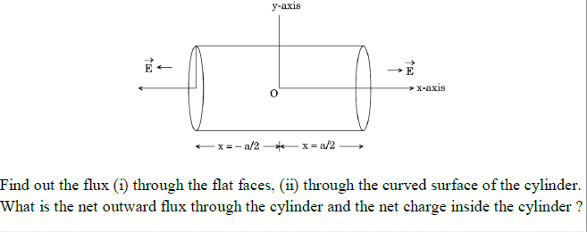
16. | If three infinite chrged sheets of uniform surface charge densities +σ , +2σ, and -4σ are placed as shown in figure, then find the electric field intensities at points A and C |  |  | 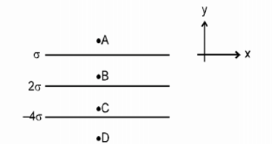 |  |  | 3
17. | Obtain an expression for torque acting on an electric dipole placed in uniform electric field? Represent it in vector form? |  |  |  |  |  | 3
 | SECTION -D
18. | a) State Gauss’s law in electrostatics. Apply this law to derive an expression for the electric field intensity at a point due an infinite long line charge of linear charge density λ. |  |  |  |  |  | 5
 | b)A point charge +q is a distance a/2 directly above the centre of a square of side b, as shown in Figure. What is the magnitude of the electric flux through the square? |  |  | 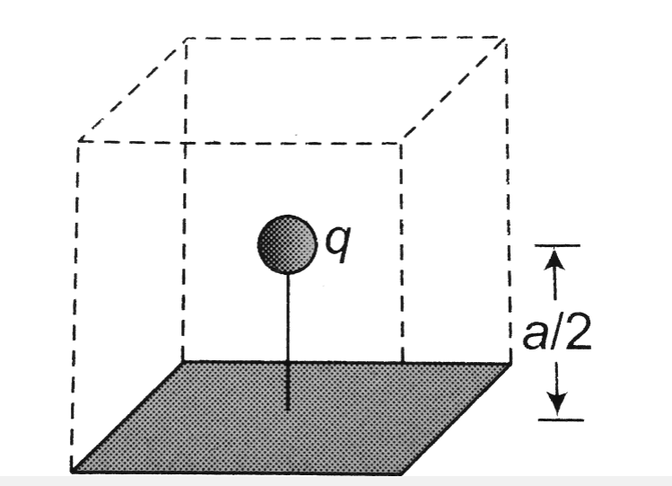
 | OR
 | a) Derive expression for electric field intensity at any point on the equatorial line of an electric dipole?
 | b)What is the angle between the electric dipole moment and net electric field intensity at any point on the equatorial line of the electric dipole?
**************************

